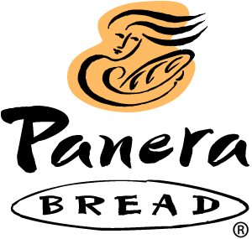


Danny Gallagher
Justin Beaudin
Ashley Pepperell
Asheton Sprague
Allie Willis
Table of Contents

Introduction . . . . . . . . . . . . . . . . . . . . . . . . . . . . . . . . . . . . . . . . 2

Situation Analysis . . . . . . . . . . . . . . . . . . . . . . . . . . . . . . . . . . . 2

Historical Content . . . . . . . . . . . . . . . . . . . . . . . . . . . . . . . . . . 2

Competitors . . . . . . . . . . . . . . . . . . . . . . . . . . . . . . . . . . . . . . 2

Products . . . . . . . . . . . . . . . . . . . . . . . . . . . . . . . . . . . . . . . . 3

Differentiation . . . . . . . . . . . . . . . . . . . . . . . . . . . . . . . . . . . . .4

Positioning . . . . . . . . . . . . . . . . . . . . . . . . . . . . . . . . . . . . . . .5

SWOT Analysis . . . . . . . . . . . . . . . . . . . . . . . . . . . . . . . . . . . .5

Objectives . . . . . . . . . . . . . . . . . . . . . . . . . . . . . . . . . . . . . . . . . 6

Target Audience . . . . . . . . . . . . . . . . . . . . . . . . . . . . . . . . . . . . .7

Advertising and Promotion Message Strategy . . . . . . . . . . . . . .9

Media Strategy and Tactics . . . . . . . . . . . . . . . . . . . . . . . . . . . 10

Execution of Advertising and Promotion Campaigns . . . . . . . 11

Conclusion . . . . . . . . . . . . . . . . . . . . . . . . . . . . . . . . . . . . . . . 13

Appendix . . . . . . . . . . . . . . . . . . . . . . . . . . . . . . . . . . . . . . . . . 14

Introduction:

Panera Bread is a well-known company all across the United States, but sales have recently decreased. They are searching for an advertising agency to rebrand their breakfast sector, and overall brand. The purpose of our marketing plan is to reengineer the face of Panera Bread. The main city we will be using to promote our new product and service is Greenville, North Carolina. Our plan brings a new audience to the breakfast market.
Situation Analysis:
Historical Context
Panera Bread came from a small company called Au Bon Pain in St. Louis, Missouri. Au Bon Pain purchased St. Louis Bread Company which was founded by Ken Rosenthall in 1993. Around the same time, renovations to the Au Bon Pain chains were taking place. After the renovations the store expanded and renamed itself Panera Bread. There are 1,453 bakery-cafes in forty states across the country. Panera Bread’s C.E.O. is William Morton. In 2005, Panera Bread was ranked 37th in Business Week’s list of “Hot Growth Companies,” earning a 42.9% increase in profits. Also, in 2009 Panera was named one of the most popular restaurants for on the go meals, Best Healthy Option, and for Best Facilities.
Competitors
In Greenville, NC, Panera Bread has a couple of main competitors located in the area that take away sales. The main target market in Greenville, NC is the college students that attend East Carolina University. With the students always on-the-go they are looking for a place that’s fast and cheap to get their breakfast in the morning.
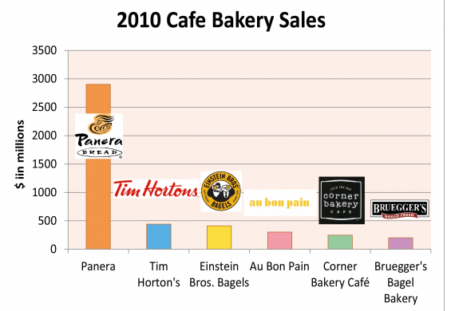
Their Main Competitors are:
- Einstein Bagels
- Bruegger’s Bagels
- McDonalds
- Starbucks
These 4 restaurants all have the tools for making a quick, cheap breakfast. Panera Bread’s goal is to take most of the sales from college students by adding a new breakfast item and service that is healthy, cheap and efficient.
Products
Panera Bread has two main areas of their restaurant. The café is where the lunch and dinner items are prepared, and the other is the bakery. In the bakery there are numerous types of freshly made items. Some include:
- Mediterranean Egg White on Ciabatta
- French Toast bagel breakfast sandwich
- Sausage, egg, and cheese
- Granola parfait
- Steel cut oatmeal
- Bagels
- Pastries
- Coffee
All of Panera Bread’s products are healthy, organic foods. Our goal is to promote the New Mediterranean Egg White on Ciabatta. This is a newly created sandwich that offers a well-balanced meal to start the day.
Differentiation
Panera Bread has a huge competitive advantage with differentiation amongst their competitors. Most of their competition is cheap and low-class, it is just a place to grab a quick sandwich on the go and not much of a place to hang out and get a feel for the environment.
The way Panera Bread differs from their competition is their high-quality. The restaurant is a classy place to go, it is well furnished, constructed, and has a very professional setting. Instead of plastic forks and knives you get to use real silverware when you eat, this is an added bonus that doesn’t make you feel like you’re eating at a low-end restaurant. The food is also very high-quality, Panera uses anti-biotic free chicken, fresh baked artisan bread, organic and all natural ingredients, and seasonal items. It is a warm environment, a place to sit down and relax with friends, and a calm area where you can access the free Wi-Fi if you want a place to work while eating a healthy breakfast.

Positioning
The way Panera Bread is positioned in the mind of the consumers is much different than what consumers think of a lower-end restaurant such as McDonalds or Brueggers Bagels. Consumers see Panera Bread as a place to eat when they are feeling health conscious. Panera Bread does offer some less healthy products such as pastries, but the majority of Panera’s options are healthy. That is what consumers see Panera as, a place to eat healthy. Customers may also have Panera programmed in their mind as a relatively more expensive place to eat, but the extra amount spent goes a long way towards the healthy and deliciously filling food.
SWOT Analysis
Strengths
- Quality of food: high quality compared to the competitors. Pride themselves on artisan breads and organic products
- Healthy food for health conscious consumers
- Well priced menu items for the quality
- Good brand name, well know, and is continuing to grow
- High customer satisfaction ratings
- Bread baking expertise, and known for the delivery of fresh dough every morning
- “Panera warmth”- lighting and music in stores lead to a more enjoyable experience
Weaknesses
- Less well known than their competitors (Starbucks, Dunkin’ Donuts)
- Focus more on breakfast and lunch menu, not so much the dinner
- Direct competitors have more locations
Opportunities
- Open more suburban outlets for extreme growth potential
- Possibility of globalizing brand
- Expanding product line to grow with current trends
Threats
- Rivals have begun to imitate Panera’s menu, opting for soup and sandwiches to go along with side salads
- New restaurant openings grab more attention
- Drive thru competitors bring in more revenue
Objectives
As a marketing agency, we have laid a framework for what a successful advertising campaign should consist of. The following is marketing objectives in detail:
Our main objectives for Panera Bread’s promotional and advertising campaign is to promote more sales traffic, build the image, change the perceptions, and grow awareness of Panera Bread. The steps we are going to take to achieve these objectives start with our new advertisements which project Panera Bread as a classier and healthier place to eat with high quality food and a nice environment. The nature of the message is going to communicate to our consumers that you can grab a quick meal for a good price and stay healthy while doing it. You can even get the meal delivered to you if you don’t have the time to go to Panera Bread to pick up your meal. The specific communication effects that we will use to get our message out there is two print advertisements that will be in newspapers, magazines, and bill boards and also a commercial advertisements to show on television.
The process we are going to use to deliver this message to our consumers is as follows:
- Trial – (informing the consumer about the product) using the 2 print advertisements and commercial
- Continuity – (reminding the consumer of the product) by showing the print advertisements in multiple areas such as newspapers, magazines, and bill boards and also replaying the commercial throughout the day
- Brand Switching (persuading the customer to change from one brand to another) by Panera Bread’s new phone application and advertising healthy products rather than the corporate fast food.
Target Audience
Our primary target audience would consist of the following:
• Females
• Ages 18-30 years old
• Young college females
• Young business professionals
• Young mother
Our first target audience is a young college female. She is a young woman living on her own either in a college dorm, apartment, or small house (usually in all of these scenarios with roommate/roommates). These living areas are typically on or near college campuses. This audience age ranges from 18-21 years old. This age tends to be the typical group of ages that eat out the most. Most women this age have just moved out of their parent’s house and are not used to cooking for themselves and usually don’t want to spend the time or don’t have the facilities. However, they do want to find a place that won’t put on the pounds like most fast food restaurants will do, which is why Panera is the perfect choice. Another demographic we have to look at is income. Although most college students don’t work full time they are still receiving income from either their parents or working a part time job. With the reasonable prices as well as varieties Panera provides a choice that is ideal anytime of the day. The general psychographic statistics for this age group tend to not only eat out more often than any other age group but also trying to find the healthiest options. The atmosphere of Panera is a classy, comfortable dining area where women can feel at ease. As you walk into Panera the message of freshness and aromas of baked bread then the sights of gourmet pastries entice your appetite. Also fulfilling the target audience’s needs Panera has up to date technology such as Wi-Fi and social media advertising that allows the college student to do homework and study while enjoying their stay.
The location of our projected advertising for this target audience would be in the college newspaper, bus stops, any shopping areas, grocery stores, health clubs, TV commercials, radio advertisements, and Internet (via emails for coupons).
Our second target audience is the young business professionals. These are women ages 21-25 years old that are college graduates or have been in the work force for a short amount of time. These women tend to live in apartments or small rental houses. For just starting their careers these women tend to have limited spending money due to outflows of paying bills, groceries, any student loans, and living life on their own. However, they are still in the age group of the typical individuals who go out to eat instead of cooking at home. This population is generally always trying to make healthy choices and the options Panera provide accomplish that lifestyle. The atmosphere is still fitting for this age group as it was described in the previous paragraph. On the other hand, this group can use the facility for small business lunches and social networking. They can also use the technology for business purposes such as checking emails, and carrying on business activities.
The locations we would advertise our ads would be the chamber of commerce, young professional magazines, shopping areas, grocery stores, and health clubs.
The last target audience is young mothers. This group is between the ages of 25-30 years old. This age group likes to get out the house and have the opportunity to meet other friends with their children. Although it’s not a child friendly place, meaning there is no child play area, it is a safe environment. This target audience is usually a first time home buyer with a small but steady income. Health is still a major concern for them and they always try to make healthy choices. The opportunity to relax and dine makes Panera a top choice for young mothers and with the variety of options they offer the food is not something you can generally make at home.
The locations we would advertise our ads would be the health clubs, preschools, newspaper, shopping areas, grocery stores, and drug stores.
Advertising and Promotion Message Strategy
With our advertisements we wanted a simple message that could be conveyed through pictures and images instead of text. We wanted a clear, obvious message that the target market would immediately understand, relate to, and remember. For our corporate advertisement we developed an advertisement that would transport the message of Panera Bread being healthy and nutritious and using real silverware instead of plastic ware. We used large pictures with silverware comparing real and plastic. In addition to the utensils we had salad on the silverware with the tagline, “Real Silverware, Real Food.” On the plastic utensils we had a piece of fried food on the fork and had the tagline say, “Fake Silverware, Fake Food.” We wanted to get the message across that Panera is a healthy place to come eat and feel like you’re eating healthy and even though they have reasonable prices, you’re not eating cheaply and enjoy the real silverware. We wanted this simple and catchy and we really got the ad we were hoping for.
For the specific ad, we chose the egg white and spinach breakfast sandwich. This advertisement was more difficult because our unique advertisement was also associated with this. We wanted to include the message of breakfast and bed and how breakfast didn’t have to be a hassle anymore. Our “wow” factor for this campaign was that we created an app for Panera Breakfast. Every phone these days have apps for everything so we thought that it would be a great idea to have a breakfast delivery app. Basically, when you go to sleep, you pull up the app and put in an order that you would like for breakfast the next morning. When your alarm goes off in the morning, the app sends to the nearest Panera and they start making your breakfast and deliver it to your door so you no longer have to worry about making breakfast and can continue to go on your day with fewer worries. Coming up with this unique factor, really motivated our advertisement for a specific breakfast sandwich. For the breakfast ad we have our breakfast sandwich, a cup of steaming coffee, and an iPhone on the dresser next to the bed. The tagline reads, “Breakfast in Bed, There’s an App for that.” Not only does it show that breakfast can be quick and easy but it also shows the fact that breakfast can still be enjoyed without being rushed and breakfast in bed is no longer something of the past. Everything else can be delivered so we thought, why not breakfast?
Media Strategy and Tactics
Our target audience being 18-30 year olds, we chose to do our advertisements in many different mediums. For our corporate advertisement we chose to put in magazines. Specifically, People, Cosmopolitan, Self, and Men’s Health magazines. We chose these magazines because we felt that it would most likely hit our main target audience and it would be effective. Most of them are health conscious magazines and our advertisement is advertising healthy food so we felt that it would become very profitable and persuasive. We knew that the magazine ads would be very costly and hard to track so we put coupons in the bottom of some of the ads in hopes to see how profitable they really became. For our specific breakfast ad, we were more selective. We chose to do newspaper ads and bill boards. We chose locations where our target market was most closely located so we could hit a mass of our audience and we also chose to do billboards. For the billboards we chose to do on very public interstates where traffic is expected and where a Panera is close to the exit and is easy on and off. This was rare so we didn’t spend too much money on this but it was costly. We thought those two ways would be most persuasive for breakfast because usually people are on the way to work, meaning they would see the billboards, or they are reading the paper before work or at work and once again they would see it. We thought for breakfast those two would be the most persuasive and non-invading. The newspaper is limited though because our target market is rare to read the paper but this is where we decided to migrate some from our target audience. Since its breakfast food, everyone eats it, so we figured it would be good to appeal to everyone on this aspect.
For the delivery app we decided to use television, magazine, and billboard mediums. We feel like those are the types of mediums that will impact our target market the hardest and will become the most recognized and profitable.
Execution of Advertising and Promotion Campaigns
For our general print advertisement for Panera Bread, we chose to demonstrate the fact that Panera Bread uses real silverware. On one side of the advertisement there is a real fork with salad on it. On the other side of the advertisement there is a plastic fork with a chicken nugget. In the middle there is a “greater than” side that shows that the real silverware is better than the plastic silverware. Underneath the picture of the real fork with the salad on it, it says “Real Silverware, Real Food.” Underneath the picture of the plastic fork with the chicken nugget on it, it says “Fake Silverware, Fake Food.” This symbolizes not only the fact that Panera Bread has better food than their competitors, but also that it’s a nicer restaurant that uses real silverware. We feel like restaurants that use real silverware are classier and more desirable than restaurants with plastic utensils. It also shows that Panera Bread isn’t considered fast food even though it is in the same price range as fast food restaurants.
For our product specific advertisement we tied it to the saying “breakfast in bed.” In this ad you will see a breakfast sandwich on a plate next to a coffee and a cell phone. All of these items are places on a tray and are on top of a bed. The advertisement says “Breakfast in bed? There’s an app for that.” This advertisement is also tied to our unique promotional project. The idea of this ad is to say that Panera Bread has good breakfast. It is also designed to attract more customers to try their breakfast items.
For our unique promotional project we chose to make an app for smart phones. The way it works is you would pick out what you want for breakfast and then set a timer for when it would send it to Panera Bread. You can either make it send when your alarm goes off in the morning or just pick a time for the order to be sent out. Once Panera Bread receives your order they will make it and deliver it to you. To demonstrate this idea we made a commercial. The first scene you see is two girls waking up in the morning and pressing a button on their phones. Then you see Panera Bread receiving their order and start preparing their food. It switches back to the girls again and you see them getting ready for the day. Then the doorbell rings and Panera Bread delivers the food to them. This commercial is targeted towards young adults since our target market is ages 18-30. The idea is that this app makes it very convenient to order breakfast because you don’t even have to leave your house. It makes life easier by making one less thing to worry about.
We will advertise the new Panera Bread app in magazines, billboards, television commercials, and their restaurants. We will put the general print advertisement in magazines only just to get our point across simply. The general public basically knows that Panera Bread is a healthier option all around so we mainly wanted to focus our bulk of advertisements on the breakfast items.
Conclusion
In conclusion, DJ and Triple A’s marketing strategy will provide an increase in traffic and sales at Panera Bread. Our strategy will promote Panera Bread’s image for the better and get their name out to more of the public. The current public trend is staying active, being fit, and eating healthy and that is what our marketing campaign is geared to do. We have great ads to fit the healthy lifestyle as well as an innovative application for your phone that will fit in with the popular social media that has taken over consumers. Our agency intends to put your best interest first, increase your sales, and promote your image and traffic flow throughout Panera Bread. DJ and Triple A will guarantee to stay motivated until the job is done.
Appendix
Media Schedule:
Corporate Ad- Magazine Media Channel
Breakfast Ad- Billboards and Newspaper
Unique Ad- Television Commercials, Magazines, Billboards
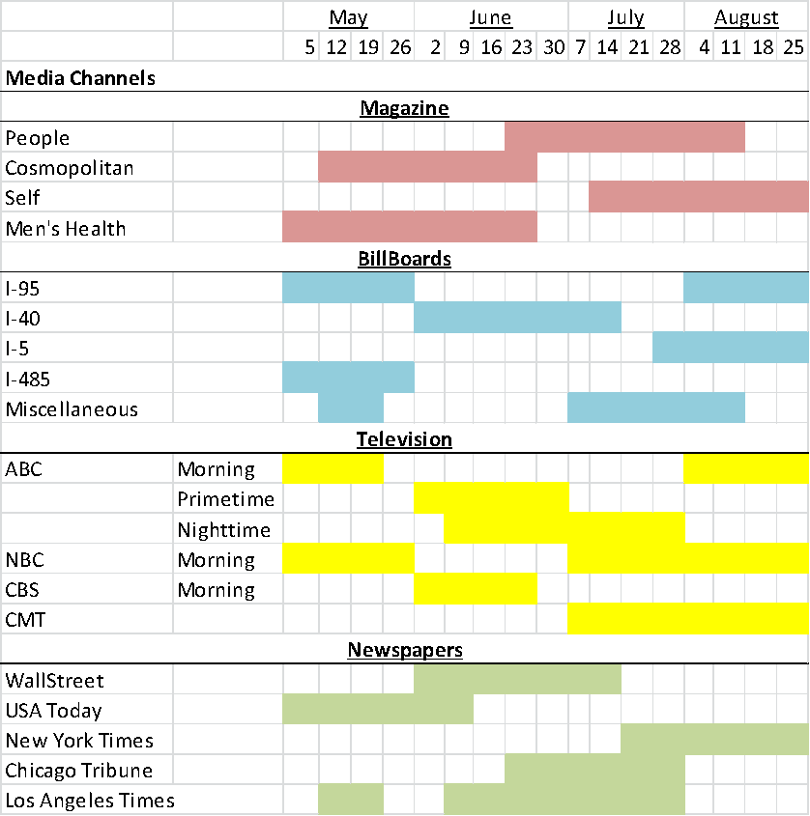

Media Budget

National TV

Setup Cost: $500,000
Media Cost: $750,000
Cost to Continue: Media Cost + hourly rate of agency ($125/hr)

Total: 1.5M/month

National Magazine

Setup Cost: $20,000
Cost of Media: $25,000
Cost to Continue: media cost + hourly rate of agency ($125/hr.)

Total: $50,000/month

National Newspapers

Setup Cost: $20,000
Media Cost: $25,000 per ad
Cost to continue: Media cost

Total: $100,000 per month

Total for 3 months: $5Million
Working Budget
2012 May-September Working Budget

Print 1
Copy and Concept (5.5 hours @ $100/hr) = $550
Agency Producer (5.5 hours @ $100/hr) = $550
Account Service (10 hours @ $100/hr) = $1000
Magazine Production (20% agency mark up) = $ 1,450

Sub Total = $ 3,550 X 3
Print 2
Copy and Concept (6 hours @ $125) = $750
Agency Producer (5 hours @ $130) = $650
Account Service (5 hours @ $125) = $625
TV Production (20% agency mark up) = $2,200

Sub Total = $4,225 X 3
Print 3
Copy and Concept (6 hours @ $125) = $750
Agency Producer (5 hours @ $130) = $650
Account Service (5 hours @ $125) = $625
TV Production (20% agency mark up) = $2,200

Sub Total = $4,225 X 3

Total: = $36000X 3months
= $108,000

Application = $1million
Design
Staff
Maintenance

Agency Salaries

CEO = $1M
Project Manager = $750,000
Account Planner = $500,000
Media Planner =$150,000
Creatives =$100,000

Total = 3.5 M
Creative Briefs
General Print Ad Creative Brief

Submitted By
DJ & Triple A

Product/Brand/Service
Product: Corporate print advertisement
Brand: Panera Bread

Key Facts
Panera Bread wants to inform all of their customers about their healthy menu. This print ad demonstrates how their food is healthier than all of their competitors.

Problem the Advertisement/Promotional Material Must Solve
With this print ad, Panera Bread is trying to get more people to come to their restaurant over their competitors.

Advertising Objective
Our general print advertisement is a picture of a real fork with salad on it and a plastic fork with a chicken nugget on it. Under the real fork it says “Real Fork, Real Food” and under the plastic fork it says “Fake Fork, Fake Food.” This ad is supposed to explain how Panera Bread is better than all of their competitors because they have healthier food and real silverware.

Target Audience
Age: 18 to 30
Gender: Geared towards females
Demographics:
-Middle Class
-Health-conscience
-Active
-Suburbs and cities
-College degree
-Home owners
Psychographics:
-Healthy, active lifestyle
-Positive attitude
-Motivated
-Employed

Key Competitors
Starbucks
McDonalds
Einstein Bagels
Bruegger’s Bagels

Key Promise – The Single Most Important Message to be Communicated
To provide a nutritious and healthy meal at a fairly low cost.
Reason Why – Supporting Rational and Emotional Reasons to Believe
If you want to keep a healthy lifestyle, you have to continually eat healthy foods. It will keep you fit and keep your brain functioning all throughout the day.

Call to Action
When customers see this ad, we hope they are encouraged to go eat at Panera Bread.

Mandatories
Panera Bread
518 Greenville Boulevard Southeast
Greenville NC 27858
(252) 317-8787

http://www.panerabread.com/

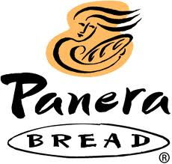

Breakfast Creative Brief

Submitted By
DJ & Triple A

Product/Brand/Service
Product: Mediterranean egg white on Ciabatta bread. An egg white with spinach on Ciabatta bread.
Brand: Panera Bread
Service: Breakfast delivery.

Key Facts
Panera Bread has low traffic in the morning during breakfast hours. Our job is to promote their breakfast items in order to generate more profit.

Problem the Advertisement/Promotional Material Must Solve
Our advertisements are designed to generate more traffic flow and sales during breakfast hours. Our phone application will produce more sales during morning hours by making it easier for customers to get breakfast.

Advertising Objective
Our product specific advertisement is a picture of the Mediterranean egg white on Ciabatta bread on a food tray placed on top of a bed. It also has a smart phone with our Panera Bread application on the screen. This advertisement is supposed to signify how easy breakfast in bed is. It also advertises our new Panera Bread delivery system.
Our general print advertisement is a picture of a real fork with salad on it and a plastic fork with a chicken nugget on it. Under the real fork it says “Real Fork, Real Food” and under the plastic fork it says “Fake Fork, Fake Food.” This ad is supposed to explain how Panera Bread is better than all of their competitors because they have healthier food and real silverware.
Our unique promotional project is a storyboard explaining our delivery service through the phone application. They storyboard explains how the app works from start to finish. This app is designed to produce more sales during breakfast hours.

Target Audience
Age: 18 to 30
Gender: Geared towards females
Demographics:
-Middle Class
-Health-conscience
-Active
-Suburbs and cities
-College degree
-Home owners
Psychographics:
-Healthy, active lifestyle
-Positive attitude
-Motivated
-Employed

Key Competitors
Starbucks
McDonalds
Einstein Bagels
Bruegger’s Bagels

Key Promise – The Single Most Important Message to be Communicated
To provide the most healthy and nutritious breakfast to start your day on the right side of the bed.

Reason Why – Supporting Rational and Emotional Reasons to Believe
If you want to keep a healthy lifestyle, you have to continually eat healthy foods for breakfast. It will keep you fit and keep your brain functioning all throughout the day.

Call to Action
When customers see this ad, we hope they are encouraged to either use our delivery app or go to Panera Bread for breakfast.

Mandatories
Panera Bread
518 Greenville Boulevard Southeast
Greenville NC 27858
(252) 317-8787

http://www.panerabread.com/

Phone App Creative Brief

Submitted By
DJ & Triple A

Product/Brand/Service
Product: Panera Bread Phone Application
Brand: Panera Bread
Service: Breakfast delivery.

Key Facts
Panera Bread has low traffic in the morning during breakfast hours. Our job is to promote their breakfast items in order to generate more profit. Using this app will make it easier for customers because they don’t have to leave the house to get breakfast.

Problem the Advertisement/Promotional Material Must Solve
Our advertisements are designed to generate more traffic flow and sales during breakfast hours. Our phone application will produce more sales during morning hours by making it easier for customers to get breakfast.

Advertising Objective
Our unique promotional project is a storyboard explaining our delivery service through the phone application. They storyboard explains how the app works from start to finish. This app is designed to produce more sales during breakfast hours.

Target Audience
Age: 18 to 30
Gender: Geared towards females
Demographics:
-Middle Class
-Health-conscience
-Active
-Suburbs and cities
-College degree
-Home owners
Psychographics:
-Healthy, active lifestyle
-Positive attitude
-Motivated
-Employed

Key Competitors
Starbucks
McDonalds
Einstein Bagels
Bruegger’s Bagels

Key Promise – The Single Most Important Message to be Communicated
To provide the most healthy and nutritious breakfast to start your day energized without the stress of having to make your own breakfast .

Reason Why – Supporting Rational and Emotional Reasons to Believe
If you want to keep a healthy lifestyle, you have to continually eat healthy foods for breakfast. It will keep you fit and keep your brain functioning all throughout the day.

Call to Action
When customers see this ad, we hope they are encouraged to use our delivery app and order breakfast.

Mandatories
Panera Bread
518 Greenville Boulevard Southeast
Greenville NC 27858
(252) 317-8787

http://www.panerabread.com/

Sample Advertisements
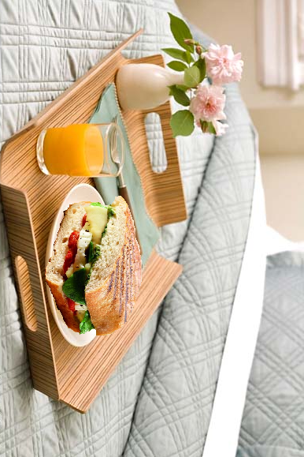
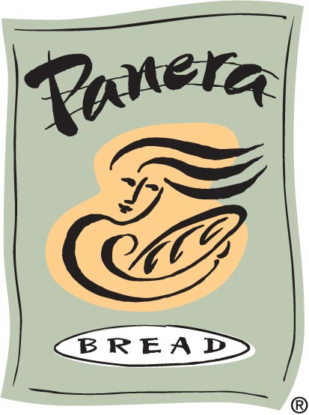
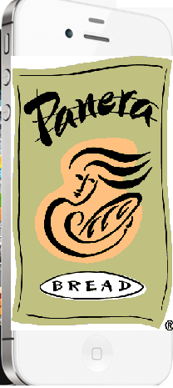
Breakfast in bed…
There’s an app for that.



